Using the ArduEye User Interface

The ArduEye user interface uses the serial port connection on the arduino pro mini to transmit datasets for viewing. The serial interface is very slow compared with modern protocols such as USB. The UI is thus useful primarily for getting an intuitive sense of what is happening on the sensor. It does not run at real-sensor time. For real time operation, the sensor should be used in embedded-only mode.
Raw Images are the largest datasets and hence the slowest to transmit. Higher resolution images are slower than lower resolution images. To get a clearer view of what is happening with the optical flow, display optic flow alone, without the raw image. The optic flow dataset is much smaller and the UI will run much closer to real speed when only optic flow is displayed.

This is how the UI looks on startup.
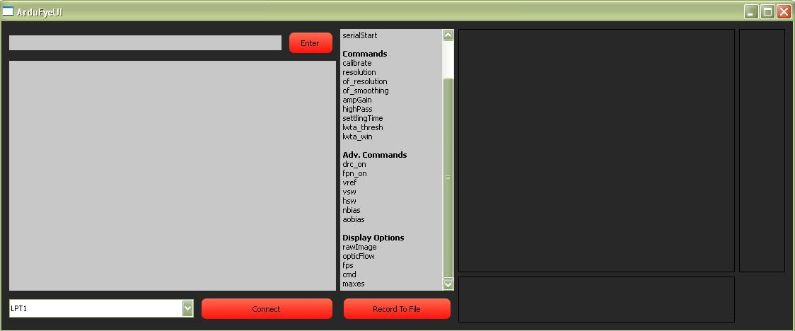
To use the UI, first connect the ArduEye sensor by selecting the appropriate serial communication port from the drop down menu and pressing “Connect”. The serial port will have the following format depending on your operating system:
Windows: \\.\COM18
Mac:
Linux:
The com port name should match the port you would use for your ArduEye Arduino board with the Arduino ide.

The Command response box will report a successful connection:
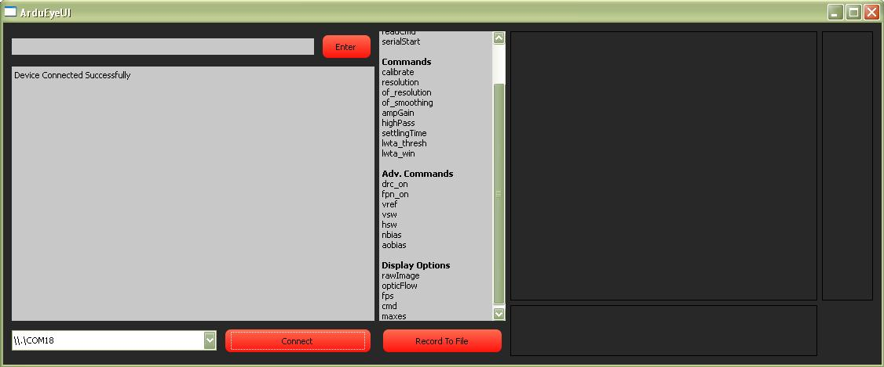

Now you can begin to send commands to the ArduEye. Available commands are listed in the command list box (the center box) on the UI. They are grouped into types. Types are listed in bold. The top group in the command list box is “Prefixes”. All commands will start with one of the prefixes. The following command formats are valid:

writeCmd [Command / Adv.Command] [Value(s)] send command to the ArduEye
display [Display Option] request datatype for UI display
stop [Display Option] stop display datatype on UI
readCmd print current command settings for the ArduEye
serialStart request the ArduEye to start sending data to the UI (If the ArduEye is running in UI mode, serial data is sending to the UI by default)

Example Command Sequence

Serial Connection Issues / Instructions and serialStart usage (see evernote notes on tests)

Appendix A: Currently Implemented Commands and Datasets
Note: These apply to the Stonyman chip which is the current ArduEye chip. A different set of commands could apply to another vision chip, although many of the basic commands will remain the same

Note 2: the ArduEye stores some settings to flash (the commands returned by the cmd dataset are the same commands that are stored to flash). For these commands, default startup settings are changed by the user. Defaults listed below are factory defaults.

Commands
Command | Description | Valid Values | Default
calibrate | generates a new fixed pattern noise mask for the sensor. The mask is generated for every available resolution and is stored in the on-board flash. During calibration, the sensor should point at a uniform area, such as a blank sheet of paper. | - | -
resolution [rows] [columns] | sets a new resolution for the raw image. | Row, cols : {112, 56, 28, 14} | 14, 14
of_resolution [rows] [columns] | sets a new resolution for the optic flow computation. The raw image will be split into rowXcolumn bins and optic flow will be computed individually for each bin. | Rows, cols: 1-16  A minimum of 4x4 pixels is required to be in each bin, so higher optic flow resolutions will not be valid for low resolution raw images | 3, 3
of_smoothing [value] | sets the smoothing rate for optic flow computations. Value is the percentage smoothing rate, eg a value of 10 corresponds to a 10% smoothing rate. At 10% smoothing, optic flow values are smoothed over 10 frames. | 0-100
HighPass [value] | Sets the high pass filter level on the raw image. This value is ignored if the high pass filter is not active | 0 – 8
lwta_thresh [value] | Brightness threshold for selecting local winners in the max points algorithm. | 0-255
lwta_win [value] | Window size for searching for local winners in the max points algorithm | 4 – image resolution
drc_on [ 1 / 0 ] | Turns dynamic range compensation on or off. When on, pixel values will be scaled to fill the full 0-255 range | 1 or 0 | 0
fpn_on [1 / 0] | Turns fixed pattern noise compensation on or off. When on, the sensor calibration mask will be applied to all acquired images | 1 or 0 | 0

Advanced Commands
Command | Description | Valid Values | Default
ampGain [value] | sets the amplitude gain level for the stonyman chip | 0-5
SettlingTime [value] | Time between setting pixel index and reading out pixel value in microseconds | 0-10
vref [value] | Set voltage reference for pixel amplifiers | 0 – 65, 65 is lowest voltage level, 0 is highest
vsw [value] | Vertical switches for pixel binning. See Stonyman datasheet for details | 0x00 : 0xFF
hsw [value] | Horizontal switches for pixel binning. See Stonyman datasheet for details | 0x00 : 0xFF
nbias [value] | See Stonyman datasheet for details | 0 – 65, 65 is lowest voltage level, 0 is highest
aobias [value] | analog out bias. See Stonyman datasheet for details | 0 – 65, 65 is lowest voltage level, 0 is highest

Currently Implemented Datasets
For details on Dataset formats, see “Hacking the ArduEye”

rawImage
grayscale image
opticFlow
optic flow for X and Y dimensions
at the requested resolution
fps
frames per second – time it takes the sensor to compute one frame
cmd
data dump of all current command settings
maxes
indices of brightest points in the image

